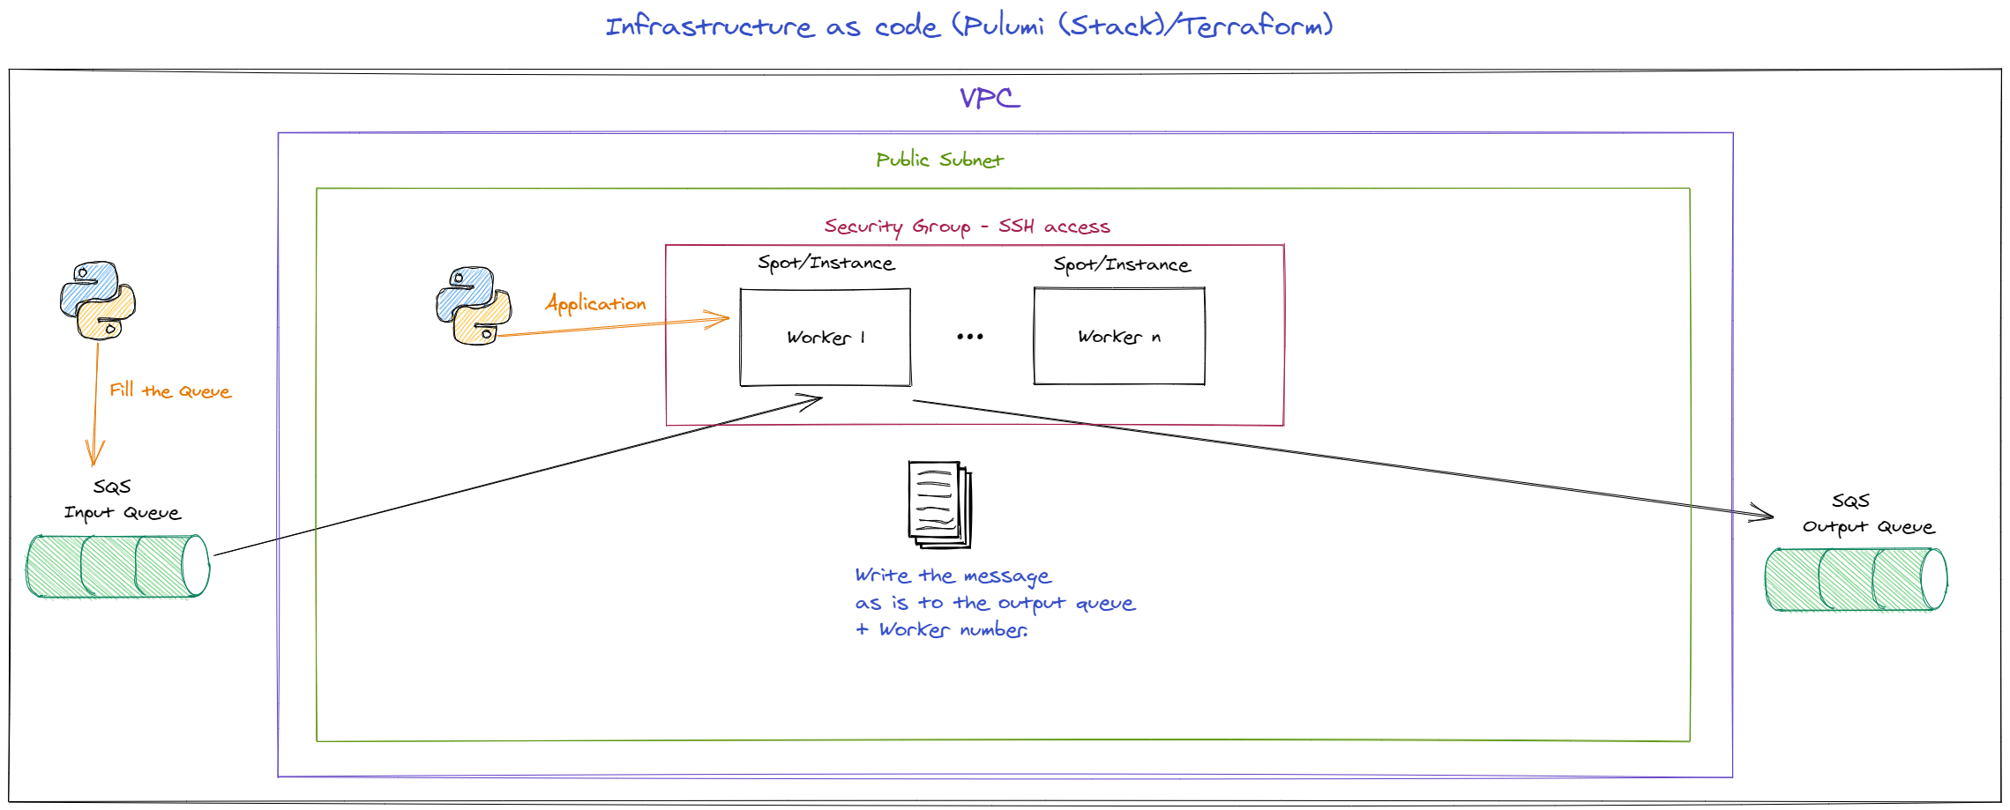

Infrastructure:
Using terraform(or any other) to create the following infrastructure:
- VPC and networking resources(subnet, etc...) in region us-east-1.
- SQS:
  - Incoming queue.
  - Outgoing queue.
- EC2 spot instances (named workers).
  - instance type should be configurable but the default is t2.micro.
  - Ubuntu 18.04 latest minor.
  - The amount of EC2 spots to launch must be configurable.
  - spot price should be configurable but you should use the default.
  - Use “interview” as key pair name.
- Security group with ssh access ( 0.0.0.0/0 inbound) for verification.
  - EC2 spots should be in this SG.
- Make sure to tag all resources with a specific variable.
Output:
- Make sure to output the IP addresses (optional - resources(instance ids)).
- Make sure to output the SQS queue urls.

Application:
Write a simple python(or any other language) application that will:
- pull a message from the incoming queue.
- write a message to the outgoing queue.
  - the message must contain the original message along with the worker’s name (EC2 spot).
- The application must run on the EC2 spot and wait for messages on launch.

Delivery:
- Code for the infrastructure.
- Code for the application.
- Bonus - a script to write messages to the queue from your local machine.

To test if everything is working, write a message to the queue and verify that the outgoing queue received it with the EC2 spot name.

